Chapter 8 Special relativity
Chapter Test Total marks 41
Name: __________________________ Class: ______ Date: ______
A data sheet with appropriate physics constants will be provided for this test.
Question 1
For changes in velocity measured in two different frames of reference to be the same, what must be true for the frames of reference? What name is given to this type of frame of reference? (2 marks)

Question 2
a Galilean relativity states there is no absolute velocity; rather, all velocities are relative. Using an example, explain what this means. Your example should use numerical values. (3 marks)

b How does special relativity contrast to Galilean relativity in respect of velocity?
(1 mark)

Question 3
The second of Einstein’s postulates in the special theory of relativity states that speed of light is a constant, independent of the motion of the light source or the observer. In other words, the speed of light is always 3 × 10⁸ m s⁻¹.
Explain what this implies in terms of space and time. (2 marks)

Question 4
Two spaceships are travelling past Earth side by side at the same high velocity. The captain of the first spaceship sends a radio signal (hence it is travelling at c) to the captain of the second spaceship. The captain of the second ship then sends a return signal. This situation is illustrated below.
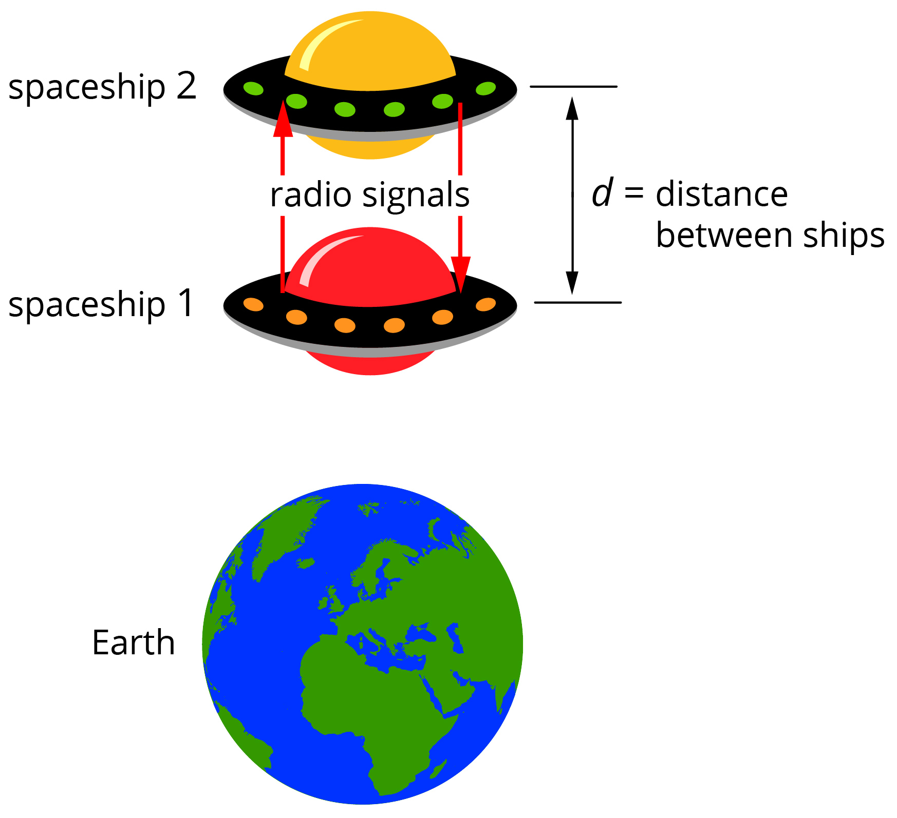
The captains of the spaceships record the time for the signals to pass between them as less than what an observer at the space command centre on Earth records. With the aid of a labelled diagram and a supporting description, explain this apparent contradiction.
(5 marks)

Question 5
a One of the pieces of evidence to support Einstein’s special theory of relativity is the observation of the half-lives of muons, which travel at speeds close to the speed of light. If the rest half-life of a muon is 2.2 × 10⁻⁶ s, what is the half-life of a muon travelling at 0.7c? (3 marks)

b If an observer was able to travel with the muon to measure its half-life, what would be the measured half-life? Justify your answer. (2 marks)

Question 6
a A comet is travelling away from Earth at a speed of 0.18c. A space probe that has been sent to observe the comet measures its long axis to be 3.2 km. When the long axis is travelling directly away from the Earth, what length will the comet appear to be from the Earth? (3 marks)

b The comet is rotating on its axis such that the long axis is at times vertical to the Earth. What length will the comet appear to have for an Earth observer when it is in this position? (1 mark)

Question 7
A probe is being sent to a planet outside our solar system. From Earth the planet is measured to be 40 light years away. At what velocity does the probe need to travel to give a distance of 20 light years? Your answer can be expressed in terms of the speed of light (c). (3 marks)

Question 8
Two space probes are launched from a space station in opposite directions, each with a speed of 0.75c.
a What is the speed of the second probe relative to the first? Your answer can be expressed in terms of c. (3 marks)

b What is the speed of the first probe relative to the second? (1 mark)

Question 9
Further evidence in support of Einstein’s special theory of relativity is the larger than expected increase in the radius of a charged particle when its velocity is increased in a magnetic field. For example, if the speed of an electron in a magnetic field of constant strength is increased from 0.2c to 0.4c, classical physics predicts the radius should increase by a factor of 2 but it is observed to increase by a factor of 2.14.
Explain this observation using the appropriate physics concepts, including appropriate formulae. Note: calculations are not necessary. (4 marks)

Question 10
A conclusion of the special theory of relativity is that no object can reach or exceed the speed of light. Explain this conclusion. (2 marks)

Question 11
A meson of rest mass 2.4 × 10⁻²⁸ kg travels at 0.85c.
a Calculate the meson’s kinetic energy at this speed. (4 marks)

b If while travelling at this speed the meson decays completely to electromagnetic radiation, what energy is released with the radiation? (2 marks)

